

Engineerica Systems, Inc.
POB 677096
Orlando, FL 32867-7096


http://www.AccuTrack.org

Version 12

What’s New?
Revision 1.2

August 16, 2012

© 2002 - 2012 Engineerica Systems, Inc.
All Rights Reserved

Welcome to AccuTrack 12 3
Filters 4
Buttons 5
Sign-in 5
Sign-out 6
Activities 7
Service Types 8
Appointments 9
Reports 12
Messaging 13
Import Wizard 15
Notes 16
Email 18
Other Changes 19

Welcome to AccuTrack 12

AccuTrack 12 is the result of many months of hard work. We started with version 10 and added features requested by its users. We also came up with our own ideas. The result is a comprehensive list of enhancements.

The highlights include the ability to create your own notes, the ability to assign activities and service types to different labs, and much more. This document contains a description of the new features.

We would like to thank all those who contributed to version 12 by submitting feedback and improvement suggestions. Also we want to thank those who participated in the beta testing of version 12.

If you have any suggestion for improving the software, do not hesitate to tell us about it. We will continue to base enhancements to the software on your feedback. Post your ideas on the “Wish List” board of the AccuTrack online forum.

We are very excited about AccuTrack 12. We hope you will enjoy the new features as much as we have enjoyed developing them.

Filters

- Set Filter Defaults
We added the ability to set the filter defaults. We added a pin icon to the drop-down control. When the pin is pressed, it saves the selection. The selection will show when the screen is launched next time.

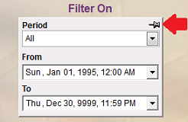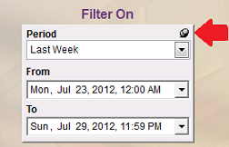

- Added “Last 7 days” to Period Selection in Reports
With this new period selection, users are able to generate reports for the last 7 days. Users can also take the advantage of this new period selection for broadcasting reports.

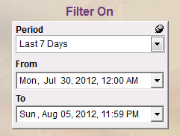

- Added “Last 7*24 hours” to Period Selection in Reports

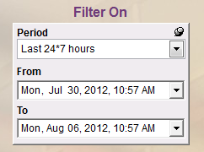

With this new period selection, users are able to generate reports for last 24*7 hours. Users can also take the advantage of this new period selection for broadcasting reports.

Buttons

- Added Graphical Icon to Attachments Button
We added a new graphical icon to Attachments button. On Tutors and Modify Students screens, users would see new graphical icon to the Attachments button when file(s) are attached.

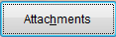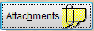

Sign-in

- Added Fixed Sign-in Fields
We added the ability to lock sign-in fields. Users can lock Category, Activity, Instructor, and Service Type on Activity screen. Users can also fix Tutor on Tutor Selection screen.

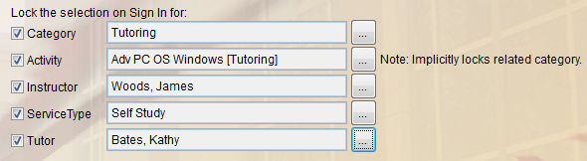

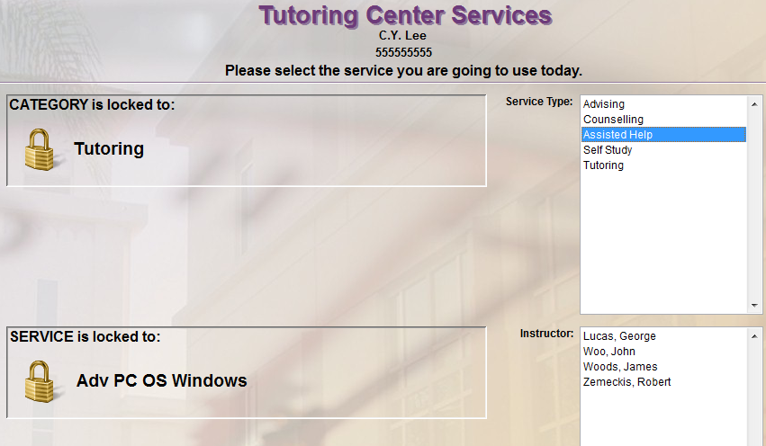

Sign-out

- Larger Font-size of Sign-out Confirmation Message
We added the ability to change the Sign-out statistics font size.

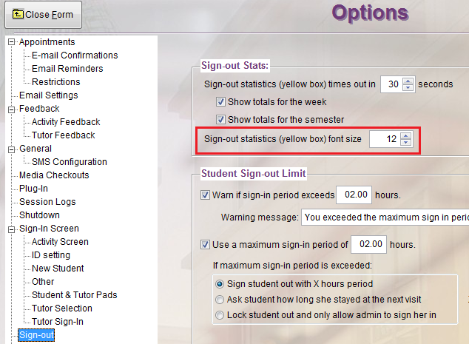

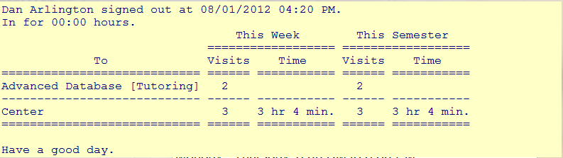

Activities

- Made Activity <-> Lab ID Many to Many Relationship
We added the ability to associate each activity/course with multiple labs instead of the single lab currently supported.

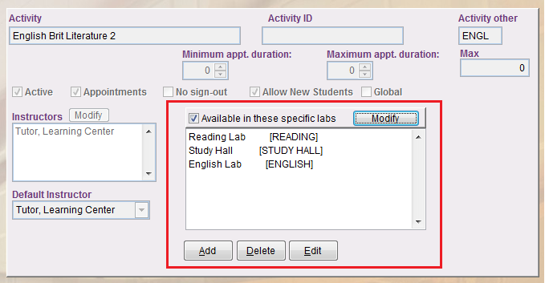

Service Types

- Made Service types <-> Lab ID Many to Many Relationship
We added the ability to associate the service type to a certain Lab ID. In previous versions all service types appeared at all labs. Now you can specify different service types for each lab.

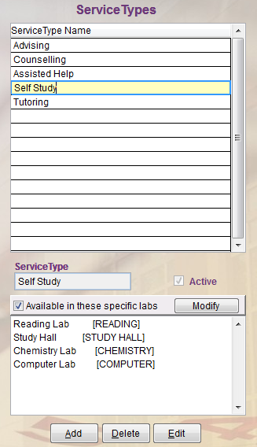

Appointments

- Added Repeat Appointment Transaction
User selects an existing appointment and the system displays the appointment information on one screen. User enters new date and time. If the tutor is available for the requested date and time, the system allows the appointment to be set and sends appointment notification email. If the tutor is not available for the entered date and time, the system provides an error message.
To repeat an appointment, go to Appointments -> View/Cancel
Select the appointment you want to repeat and click on “Repeat Appointment”.

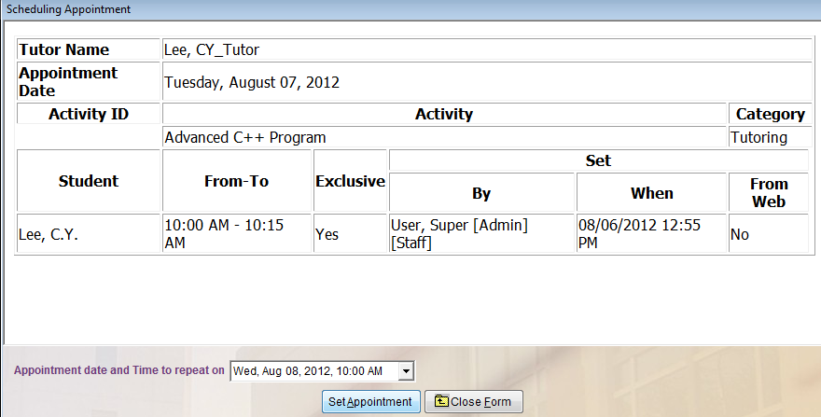

- Added "Change Tutor" within an Existing Appointment
User selects an existing appointment and the system displays the appointment information on one screen. The system displays the available tutors for the activity and highlights the currently scheduled tutor. User selects the new tutor. The system updates the appointment and sends an Appointment Change Notification Email to the student(s), original tutor and the new tutor.
To change the tutor of an existing appointment, go to Appointments -> View/Cancel
Select the appointment you want to changer tutor and click on “Change Tutor”.

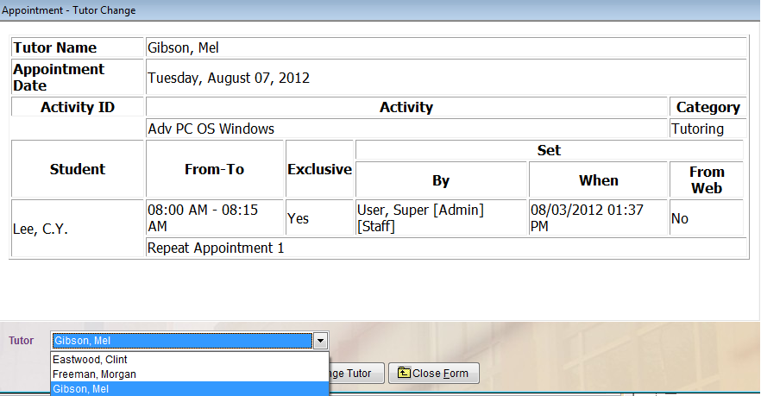

- Added "Change Location" within an Existing Appointment
We provided a feature where we could change the location within an existing appointment. Today to accomplish this we would have to cancel the original appointment and create a new one. It would be much simpler if there was a
"Change Location" option for an existing appointment transaction.
With this new “Change Location” feature, user selects an existing appointment and the system displays the appointment information on one screen. The system displays the available locations and highlights the current location. User selects the new location. The system updates the appointment and sends an Appointment Change Notification Email to the student(s) and tutor.
To change the location of an existing appointment, go to Appointments -> View/Cancel
Select the appointment you want to change location and click on “Change Location”.

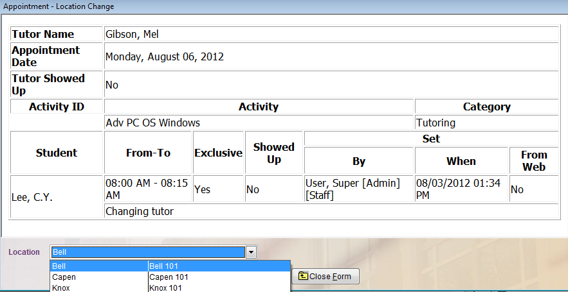

Reports

- Added Set Schedule for Instructor’s Attendance Report
We added the ability to ask students whether to report session to instructors. Users can schedule to run session report on any day and time for a period of time. The system has the ability to email reports to instructors and save reports to a folder.

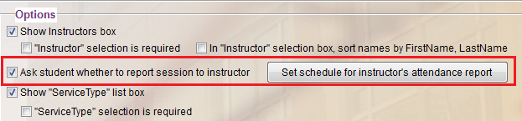

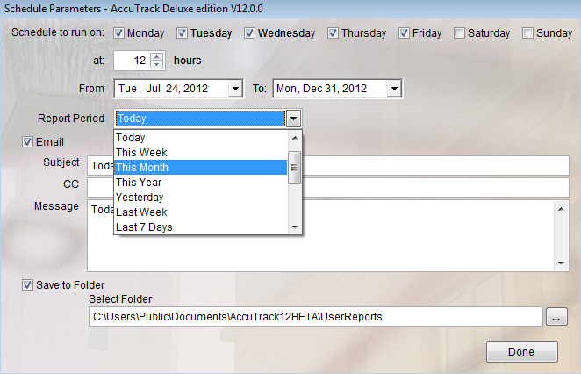

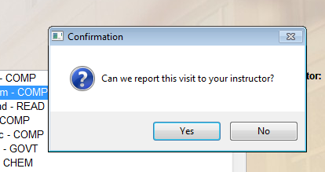

Messaging

- SMS Messages
You can send messages to students and tutors via Short Message Service (SMS). SMS is short text message sent to cell phones. We supported SMS via Skype in version 11. New to version 12 is support for Nexmo, which offers substantially less messaging fees than Skype. The last time we looked at this Skype charged 8 cents per message, while Nexmo charges less than 1 cent per message! You can also enable sending SMS on Waiting List and Intake System screens now.
To use this feature, you need to have either Skype account with Skype credits from http://www.skype.com or Nexmo account with Nexmo credits from http://www.nexmo.com

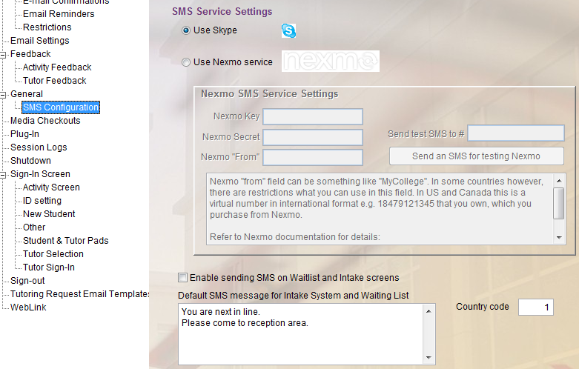

If the student does not want to receive SMS messages on his/her cell phone, check the box next to their cell phone entry box:

However, you can over-ride the opt-out option by checking the box in the Messaging Center. This might be useful in emergencies.
You can also enable sending SMS on Waiting List and Intake System screens now.

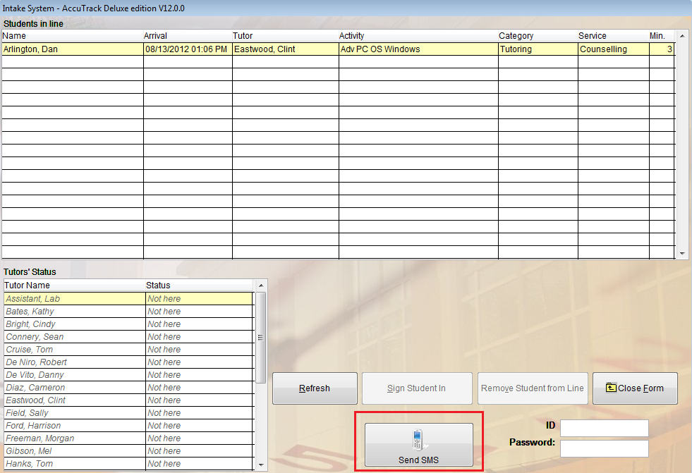

Note: You need to assign a computer to send the Skype messages. You must be logged in to your Skype account on this computer. Launch AccuTrack and check the box “Send SMS reminders from this computer” in the System Administration screen:

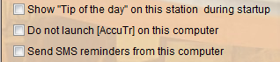

However, for Nexmo you don’t need to assign a computer, nor you need to be logged in to your account. It works similar to emailing. If you have access to internet, then that is enough for Nexmo.

AccuTrack sends SMS messages to the “Cell Phone” number entered in the student or tutor screens. If the student does not already have one in the database, the system will pop up this box via the Intake System:

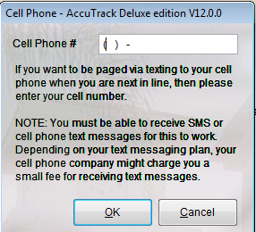

Import Wizard

- Tutor Activity Assignment Import
We added the ability to import tutor activity assignment data.

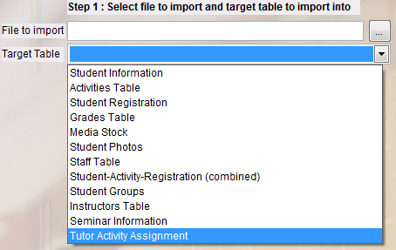

Notes

- Custom Notes
You can now right click on empty area of most screens to add a note to it. The note appears in the form of clickable button on that page.

- Right click on empty area of screen and generates this pop up:

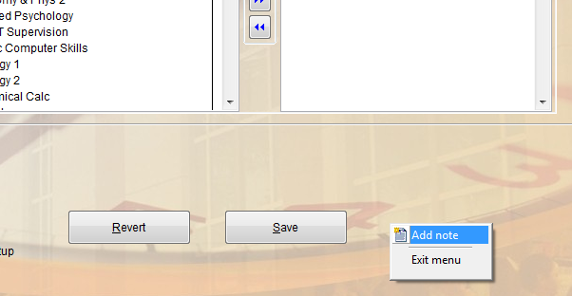

- You will see the Add Note box:

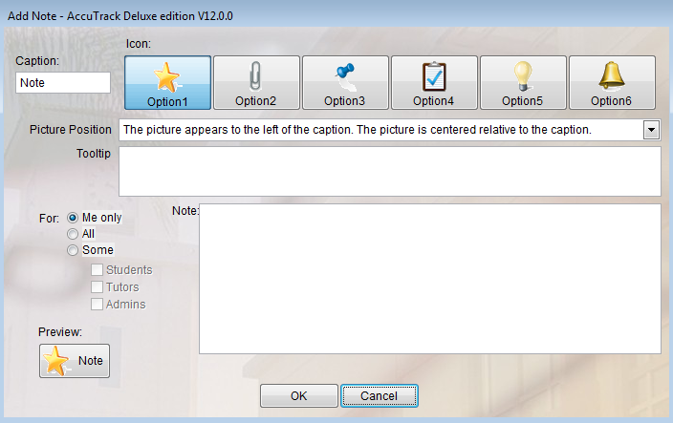

User selects caption of note button, icon, visibility (Me only, Students, Tutors, Admins, All), and enters the note’s text.

- Button will be added to where the click occurred:

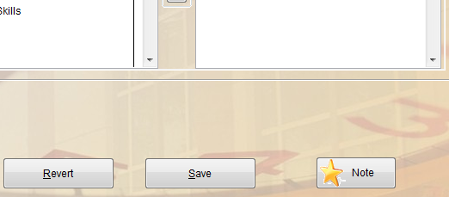

- Clicking on button with left mouse button will show the note:

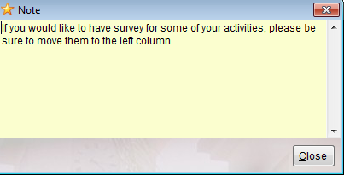

- Clicking on button with right mouse button will show options:

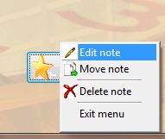

Edit Note brings up box in b above to allow changes.
Move Note allows moving the button to another location on that same screen.
Delete Note will remove the button.

Email

- Added Support for Encrypted/Secure SMTP Server
We added the ability to support encrypted/secure SMTP server. Users can now use services like Gmail for their center’s communications.

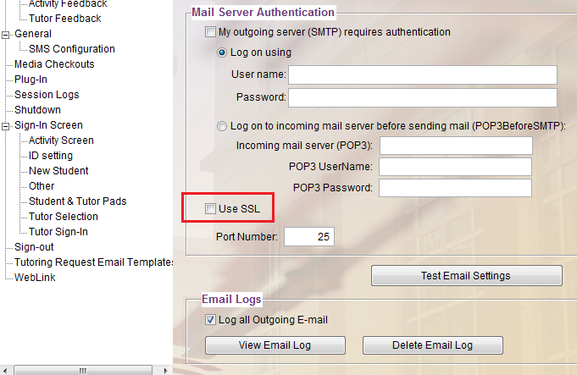

Other Changes

- Added Lab ID Filter for Intake System
Intake System (waiting list): Added a lab ID filter so only students waiting for that center are shown on the list.

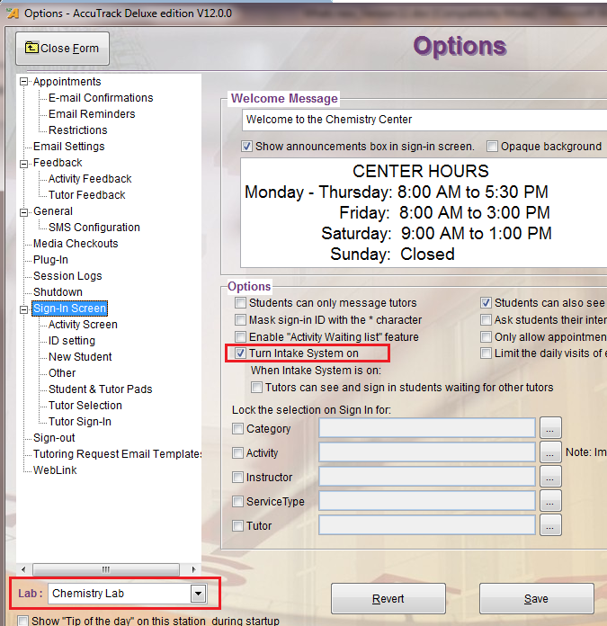

- Added Message Customization for Intake System
You can customize the message “you are next in line. Please come to reception area".

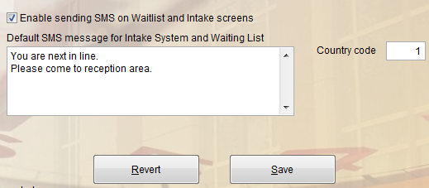

- Survey Manager: Option of having the survey automatically come up at log-in instead of log-out.

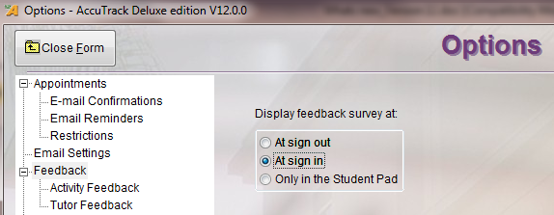

- Reports: New report for the session questionnaire filled out by the tutors.

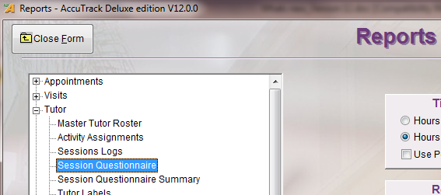

- Reports: Added a graph that shows the peak number of visitors during each hour (as opposed to number of arrivals per hour).

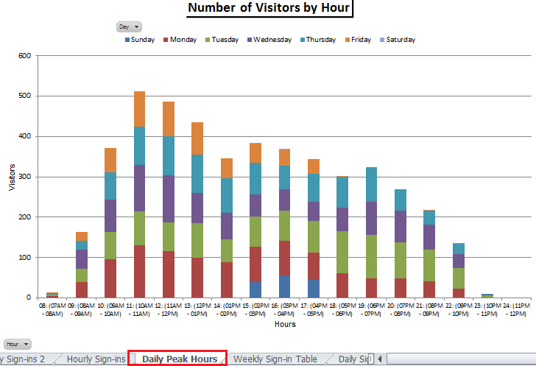

- Student Contact: When entering Student Contact information, the Reason and Contact Type will be auto completed from previous entries.

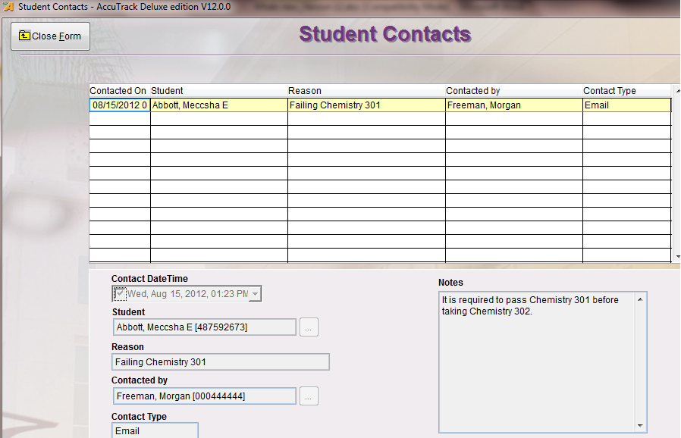

- Workshops: Ability to pull off workshop stats.

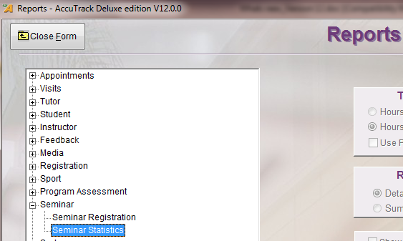

- Appointments Central: Added display of appointment notes when right click on the appointment.

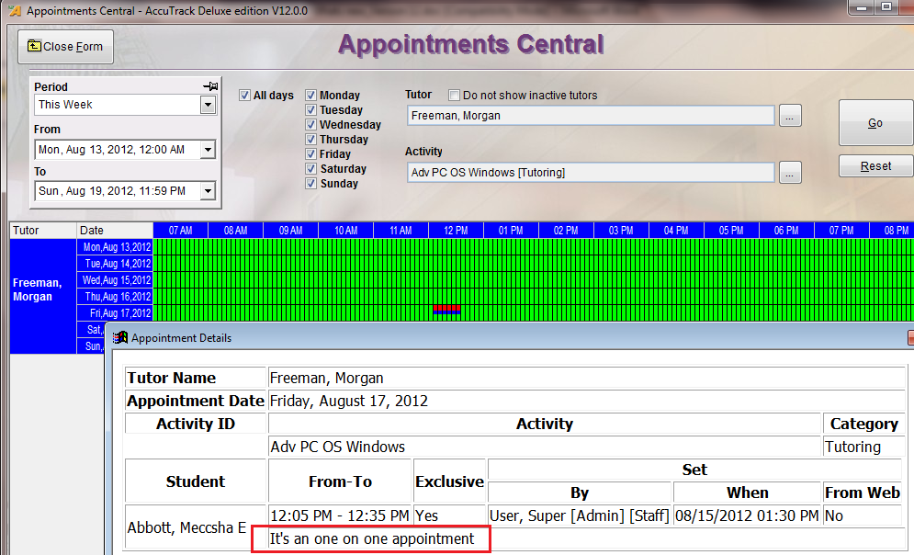

- Appointments: Added the Appointment Note to the appointment email template.

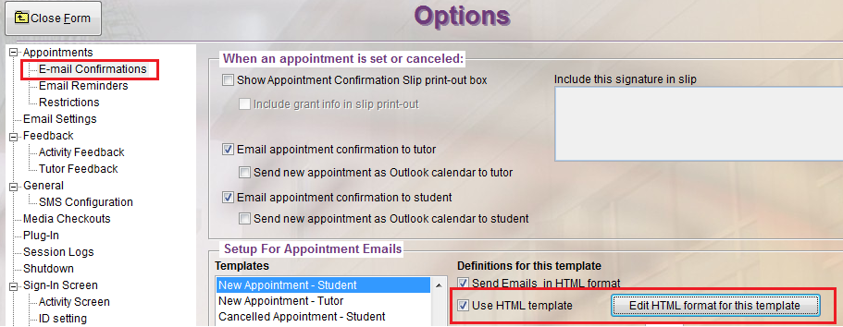

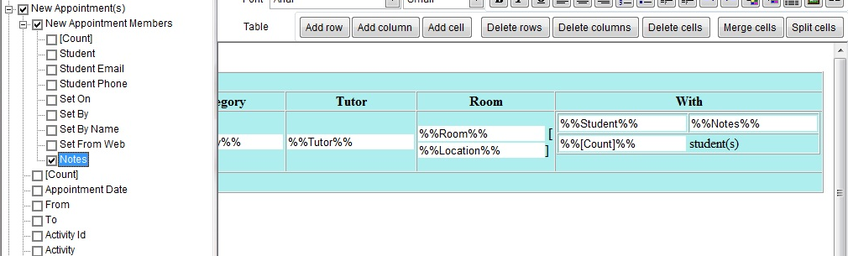

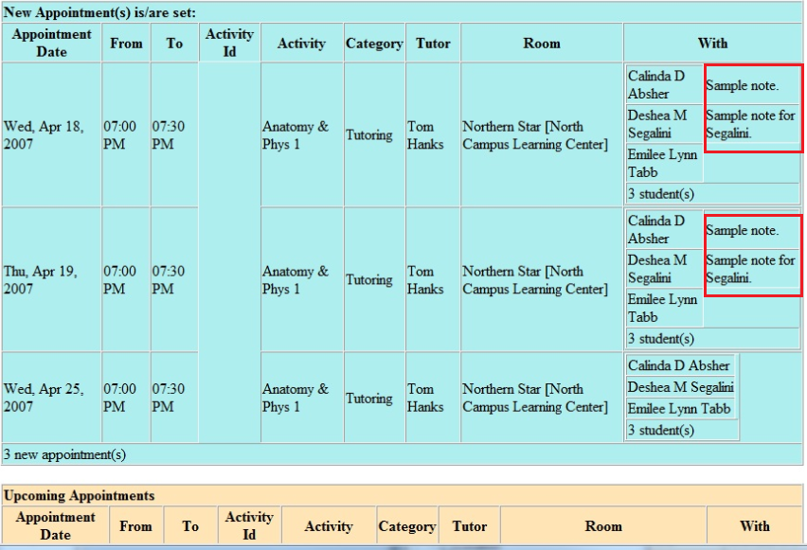

- Media: Allow entering “All media must be returned by” date.

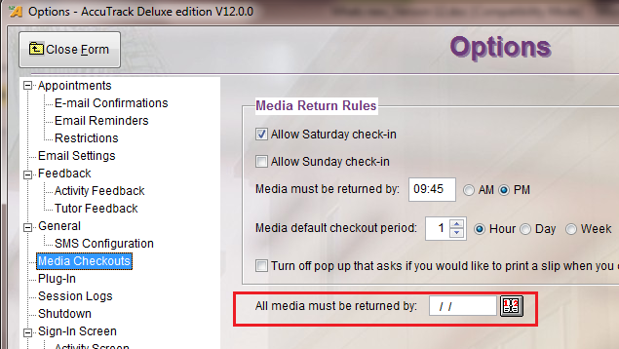

- Session Log: Added the ability to filter by Lab ID.
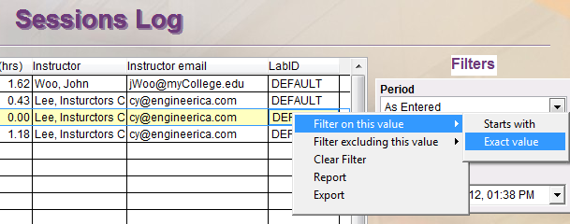

- AccuSL: Added the ability to display notes on the sign-in screen. The notes are added via an XML file that the user can update. Also added the ability to support multiple centers.



